Board Readiness Challenge Question Paper

Mathematics:
Q1. The HCF of 96 and 404 is 4. What is their LCM?
A. 969
B. 9696
C. 404
D. 384
Correct: B. 9696
Explanation:
1. Remember the relationship between two numbers and their HCF & LCM:
HCF × LCM = First Number × Second Number
2. Here, First Number = 96, Second Number = 404, and HCF = 4.
3. Substitute these values into the formula:
4 × LCM = 96 × 404
4. Divide both sides by 4:
LCM = (96 × 404) / 4 = 24 × 404 = 9696
Thus, the correct option is B. 9696.
Q2. If one zero of the polynomial p(x)=x^2-7x+12 is 3, then the other zero is:
A. 2
B. 3
C. 4
D. 5
Correct: C. 4
Explanation:
1. For any quadratic polynomial p(x) = ax² + bx + c, the sum of its zeros is given by -b/a.
2. In p(x) = x² - 7x + 12, we have a = 1, b = -7, and c = 12.
3. Sum of zeros = -(-7)/1 = 7.
4. Since one zero is 3, let the other zero be β:
3 + β = 7 ⟹ β = 7 - 3 = 4
Thus, the correct option is C. 4.
Q3. For what value of k will the pair of equations
2x+3y=7
4x+6y=k
have infinitely many solutions?
A. 7
B. 10
C. 14
D. 21
Correct: C. 14
Explanation:
1. Two linear equations a₁x + b₁y = c₁ and a₂x + b₂y = c₂ have infinitely many solutions when:
a₁/a₂ = b₁/b₂ = c₁/c₂
2. Here, a₁ = 2, b₁ = 3, c₁ = 7 and a₂ = 4, b₂ = 6, c₂ = k.
3. Setting up the ratios:
2/4 = 3/6 = 7/k
1/2 = 7/k
4. Cross-multiplying gives k = 7 × 2 = 14.
Thus, the correct option is C. 14.
Q4. The 7th term of an AP is 20 and the 13th term is 38. What is the 25th term?
A. 68
B. 74
C. 76
D. 80
Correct: B. 74
Explanation:

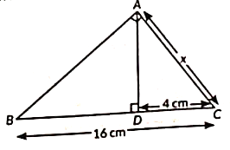
Q5. In the given figure, in ΔABC, AB ⟂ BC and ∠BAC = 90°. If BC = 16 cm and DC = 4 cm, then the value of x is:
(a) 4 cm
(b) 5 cm
(c) 8 cm
(d) 3 cm

Correct C. 8
Explanation:
1. In right-angled triangle ABC (∠BAC = 90°) with altitude AD ⊥ BC, ΔADC is similar to ΔBAC.
2. By property of similar triangles:
AC/BC = DC/AC ⟹ AC² = BC × DC
3. Given BC = 16 cm and DC = 4 cm:
x² = 16 × 4 = 64
4. Taking square root: x = √64 = 8 cm.
Thus, the correct option is (c) 8 cm.

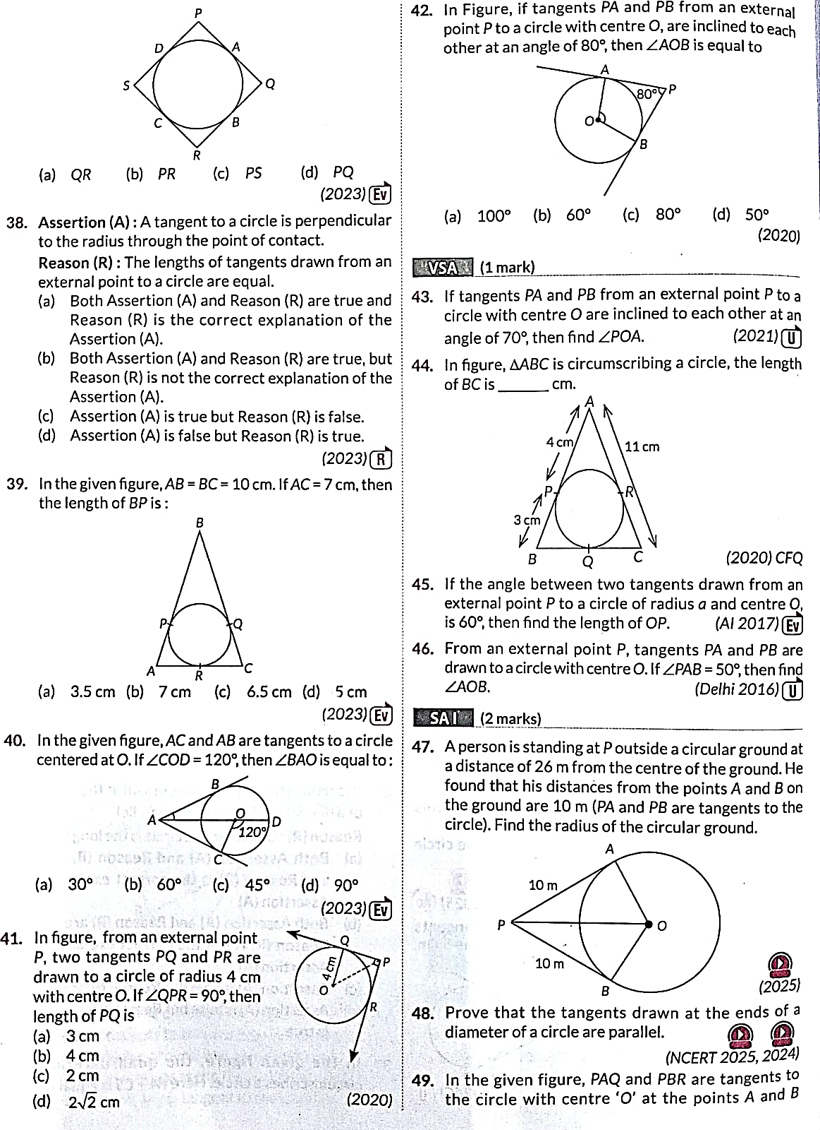
Q6. In figure, ΔABC is circumscribing a circle, the length of BC is ______ cm.
- 10 cm
- 11 cm
- 14 cm
- None of these
Correct: A. 10
Explanation:
1. Tangents drawn from an external point to a circle are equal in length.
2. From vertex A: AP = AR = 4 cm.
3. From vertex B: BP = BQ = 3 cm.
4. Side AC = 11 cm, so RC = AC - AR = 11 - 4 = 7 cm.
5. From vertex C: QC = RC = 7 cm.
6. Therefore, length of BC = BQ + QC = 3 + 7 = 10 cm.
Thus, the correct option is 10 cm.

Q7. For the following distribution: The sum of lower limits of median class and modal class is

Class | Frequency
0-5 | 10
5-10 | 15
10-15 | 12
15-20 | 20
20-25 | 9
(a) 15
(b) 25
(c) 30
(d) 35

Correct: B. 25
Explanation:
1. Modal Class: The class interval with the highest frequency (20) is 15–20. So, lower limit = 15.
2. Median Class:
- Total frequency N = 10 + 15 + 12 + 20 + 9 = 66.
- N/2 = 33.
- Cumulative frequencies: 0–5 (10), 5–10 (25), 10–15 (37).
- The 1st cumulative frequency ≥ 33 is 37, corresponding to class 10–15. So, lower limit = 10.
3. Sum of lower limits = 10 + 15 = 25.
Thus, the correct option is B. 25.

Q8. If one of the roots of the equation x^2-6x+k=0 is twice the other root, then the value of k is:
A. 6
B. 8
C. 9
D. 12
Correct: B. 8
Explanation:

Q9. A ladder 10 m long rests against a vertical wall. Its foot is 6 m away from the wall.
What is the angle made by the ladder with the ground?
A. 30∘30^\circ
B. 37∘37^\circ
C. 53∘53^\circ
D. 60∘60^\circ
Correct: C. 53∘
Explanation:
1. Let the wall and ground form a right triangle with the ladder as the hypotenuse (10 m) and foot distance as base (6 m).
2. The cosine ratio for the angle θ with the ground is:
cos θ = Base / Hypotenuse = 6 / 10 = 0.6
3. Since cos 53° ≈ 0.6, the angle made by the ladder with the ground is approximately 53°.
Thus, the correct option is C. 53°.
Q10. A solid is made by placing a cone on a hemisphere. Both have radius 3 cm. The height of the cone is 4 cm. What is the volume of the complete solid?
A. 18π cm3
B. 24π cm3
C. 30π cm3
D. 36π cm3
Correct: C. 30π cm3
Explanation:
1. Total Volume = Volume of Hemisphere + Volume of Cone.
2. Volume of Hemisphere = (2/3)πr³ = (2/3)π(3)³ = 18π cm³.
3. Volume of Cone = (1/3)πr²h = (1/3)π(3)²(4) = 12π cm³.
4. Total Volume = 18π + 12π = 30π cm³.
Thus, the correct option is C. 30π cm3.

Science:

PHYSICS (Q11 – Q14)
Q11 An electric current passes through a straight wire. Magnetic compasses are placed at the point A and B.
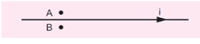
(a) Their needles will not deflect
(b) Only one of the needles will deflect
(c) Both the needles will deflect in the same direction
(d) The needles will deflect in the opposite direction
correct answer :(d) The needles will deflect in the opposite direction.
Explanation:
The current is flowing through the straight wire from left to right:
A current-carrying straight wire produces a magnetic field in concentric circles around the wire.
Use the Right-Hand Thumb Rule:
- Point your right thumb in the direction of current → left to right.
- The curled fingers give the direction of the magnetic field.
- At Point A Magnetic field it is pointing out of the plane & at Point B it is pointing into the plane.

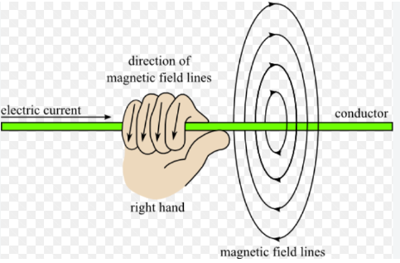
Q12 An object is placed on the principal axis of a concave lens a distance of 20 cm from it. If the focal length of the lens is also 20 cm, find the location of the image from the lens.
(a) infinity (b) +20 (c) -10 (d) -30
Correct Ans: (c) -10
Explanation:
For a concave lens, the focal length is negative according to the Cartesian sign convention.
f=-20, u = -20
Now use the lens formula:
[
\frac{1}{f}=\frac{1}{v}-\frac{1}{u}
]
[\frac{1}{-20}=\frac{1}{v}-\frac{1}{-20}]
[ \boxed{v=-10\text{ cm}} ]

What does the negative sign mean?
The negative sign means that the image is formed 10 cm in front of the lens, i.e. on the same side as the object.
This is exactly what we expect from a concave lens: it always forms a virtual, erect and diminished image of a real object.

Q13 In the given Circuit, Find the out effective resistance between A and B. Also Find out the Potential difference across 4$Ω$ resistor, if the terminals AB are connected with a 20 Volt battery.
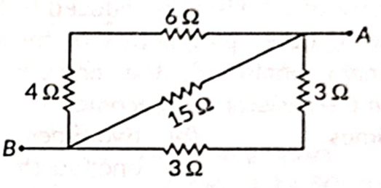
(a) 31 $Ω$, 8 Volt (b) 3 $Ω$, 4 Volt (c) 31 $Ω$, 4 Volt (d) 3 $Ω$, 8 Volt
Correct option: (d) 3 $Ω$, 8 Volt
Explanation:
There are three branches between A and B. All are in parallel conneciton:
- Total Resistance of Upper branch: 6Ω+4Ω=10Ω6\Omega+4\Omega=10\Omega
- Total Resistance Lower branch: 3Ω+3Ω=6Ω3\Omega+3\Omega=6\Omega
- Total Resistance Diagonal branch: 15Ω15\Omega
Thus, 10Ω, 6Ω, 15Ω10\Omega,\ 6\Omega,\ 15\Omega are in parallel.
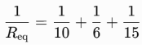
R_{eq} = 3 $Ω$
To find potential differences across 4 Ω.

Important concept
Since the three branches are connected in parallel, the potential difference across each complete branch is the same.
Therefore, the upper branch total resistance as they are in series connection is
6 Ω + 4 Ω = 10 Ω
Total voltage across the branch V=20V
V = IR
I = 2 A.
Potential difference across 4 Ω = 4×2A =8 Volt
Q14 How much power will be consumed by a resistor of resistance 12 Ω when a battery of 18 V is connected across it?
(a) 3/2 W (b) 27 W (c) 3888 W (d) 216 W
Correct: (b) 27 W
Explanation: The battery provides a potential difference of 18 V across the resistor. Since the resistor opposes the flow of charge with a resistance of 12 Ω, the current is found by using the expression (P=V²/R)
CHEMISTRY
Q15 In the chemical reaction $\text{CuO} + \text{H}_2 \rightarrow \text{Cu} + \text{H}_2\text{O}$, which species acts as the reducing agent?
A) $\text{H}_2$
B) $\text{CuO}$
C) $\text{Cu}$
D) $\text{H}_2\text{O}$
Correct Answer: A) $\text{H}_2$
Explanation: A reducing agent is a substance that reduces another substance while undergoing oxidation itself (by gaining oxygen or losing hydrogen). Here, $\text{H}_2$ gains oxygen to form $\text{H}_2\text{O}$, thereby reducing $\text{CuO}$ to $\text{Cu}$. Thus, $\text{H}_2$ is the reducing agent.
Q16 Four aqueous solutions A, B, C, and D have pH values of $2.0$, $7.0$, $9.0$, and $13.0$ respectively. Which solution contains the highest concentration of hydrogen ions ($\text{H}^+$)?
A) Solution B
B) Solution A
C) Solution C
D) Solution D
Correct Answer: B) Solution A
Explanation: The pH scale is inversely related to hydrogen ion concentration ($[\text{H}^+]$). A lower pH value indicates a higher concentration of $\text{H}^+$ ions. Solution A has the lowest pH ($2.0$), meaning it is the most acidic and possesses the highest $[\text{H}^+]$ concentration.
Q17. Study the real-world application setup shown above used for welding broken railway tracks. Which of the following correctly explains the chemical role of aluminum in this process?
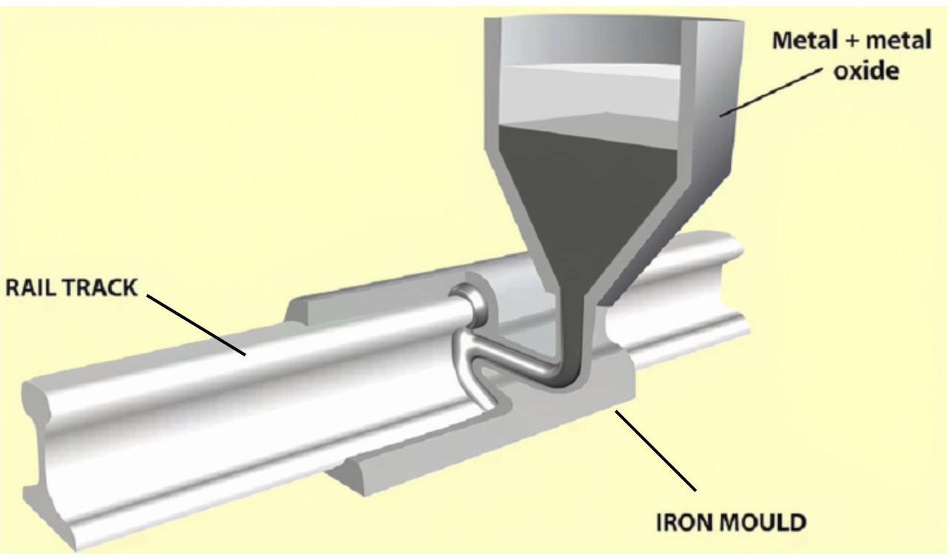
[Image description: a crucible over a cracked railway track. Inside the crucible, a high-temperature mixture of a metal powder and a metal oxide is reacting vigorously, producing molten metal that flows directly into the gap of the iron track to join it. ]
A) Aluminum acts as a catalyst that lowers the melting point of iron.
B) Aluminum is less reactive than iron and prevents the track from oxidizing further.
C) Aluminum is more reactive than iron and displaces it from its oxide in a highly exothermic reaction, producing molten iron.
D) Aluminum melts down to form a strong alloy layer directly over the crack without any chemical reaction.
Correct Answer: C
Explanation: In the thermite reaction, aluminum is more reactive than iron and displaces iron from iron(III) oxide ($Fe_2O_3 + 2Al \rightarrow Al_2O_3 + 2Fe + \text{Heat}$). This reaction releases a massive amount of heat, melting the iron so it can flow into and weld the cracked railway track.

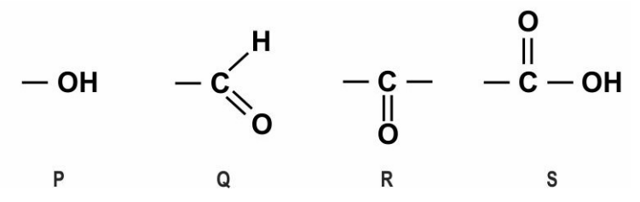
Q18 A compound with which of the following functional groups is most likely to cause the decomposition of baking soda to produce carbon dioxide?

A) P
B) Q
C) R
D) S
[Image description: The image contains the structures of four functional groups: alcohol, aldehyde, ketone and carboxylic acid labelled P, Q, R and S respectively.]
Correct Answer: D) S
Explanation: The functional group -COOH in fig. S corresponds to carboxylic acids. Carboxylic acids react with sodium hydrogen carbonate or baking soda ($\text{NaHCO}_3$) to release carbon dioxide gas ($\text{CO}_2$), which causes brisk effervescence ($\text{CH}_3\text{COOH} + \text{NaHCO}_3 \rightarrow \text{CH}_3\text{COONa} + \text{H}_2\text{O} + \text{CO}_2 \uparrow$).
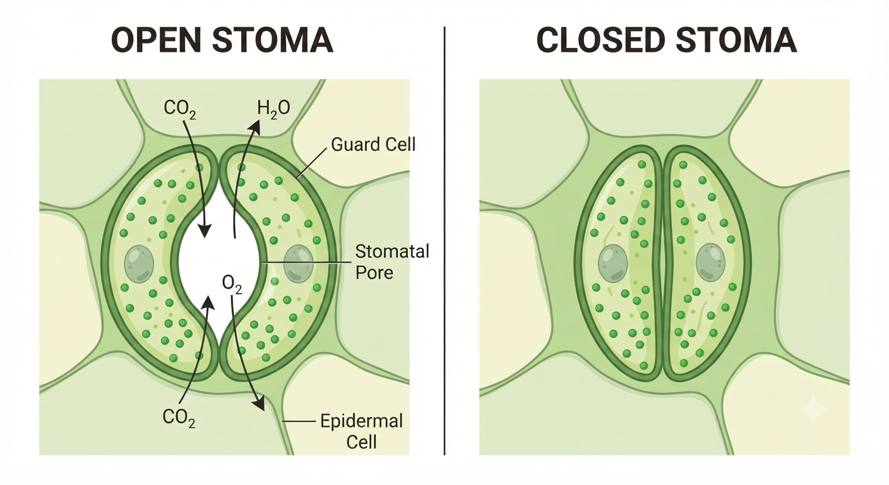
Q19 Study the diagram of the stomatal apparatus shown above. What causes the stomatal pore to open up for gaseous exchange during photosynthesis?

A) Loss of water from guard cells causing them to shrink
B) Inward movement of water into guard cells causing them to swell and bend outward
C) Accumulation of carbon dioxide gas inside the epidermal cells
D) Closure of chloroplasts to block sunlight entry
Correct Answer: B (Inward movement of water into guard cells causing them to swell and bend outward)
Explanation: When water flows into the guard cells, they swell and bulge outward due to their thicker inner walls, causing the pore between them to open. When water flows out, the guard cells shrink and the pore closes.

Q20 When a homozygous tall pea plant ($TT$) is crossed with a homozygous dwarf pea plant ($tt$), all $F_1$ offspring are tall ($Tt$). What percentage of plants in the $F_2$ generation is expected to be heterozygous tall?
A) $25\%$
B) $50\%$
C) $75\%$
D) $100\%$
Correct Answer: B) $50\%$
Explanation: Self-pollination of $F_1$ plants ($Tt \times Tt$) yields $F_2$ offspring with the genotypic ratio $1\ TT : 2\ Tt : 1\ tt$. Heterozygous tall plants ($Tt$) account for $2$ out of $4$ total combinations, which equals $\frac{2}{4} = 50\%$.

